

Library Management System

J Ganesh AP21110011196

Shyam Sai AP21110011197

Satya Priya AP21110011198

K C S N V SATYANARAYANA AP21110011199

T Nikhil AP21110011200

**Table of contents:**

1. Abstract

2. Introduction

3. Existing System/Literature review

4. System Requirements

5. Proposed System

6. Results/Screenshots

7. Conclusion

8. References

1. Abstract

The library management system (LMS) is like a super smart helper for libraries. It does a lot of important things to keep everything organized and running smoothly. It helps librarians keep track of books. The system is easy to use for both library staff and students, making everyone's experience better.

One big focus of the library management system is keeping everything safe and private. It follows strict rules to protect people's information and make sure data stays secure. The system is also really good at handling lots of information and many people using it at the same time, which keeps the library running smoothly without any interruptions.

Another great thing about the library management system is that it works on different types of computers and devices. This makes it accessible to everyone and more convenient to use. It also follows all the important laws and rules about managing libraries and protecting data.

Overall, the library management system is a super important tool for modern libraries. It helps make things easier for librarians, improves the experience for students, and ensures that everything in the library runs efficiently and safely.

1. Introduction

* A library management system is a comprehensive software solution for libraries.
* It includes features for cataloging books, managing member information, tracking books, and generating reports.
* The system has a user-friendly interface for easy navigation by staff and patrons.
* It is scalable and performs well even with large amounts of data and multiple users.
* Compatible with various operating systems and devices for accessibility.
* We provide regulations related to library management and data privacy.
* Regular updates and maintenance to keep the system secure and functional.
* Advanced reporting and analytics capabilities provide valuable insights for administrators.

1. Existing System/Literature review

Introduction to Library Management Systems:

* Define the scope of your library management system, focusing on the admin and student functionalities.
* Highlight the importance of efficient management for both administrators and students in a library context.

Role of Admin Users:

* Discuss the responsibilities and tasks typically handled by admin users in a library setting.
* Review existing literature on the features and functionalities required in an LMS to support admin tasks effectively.

Role of Student Users:

* Describe the needs and expectations of student users when interacting with a library system.
* Explore literature on user experience design principles for student interfaces in LMS.

Existing LMS for Admins:

* Review literature and case studies on LMS platforms designed specifically for administrators.
* Discuss key features such as catalog management, circulation control, reporting tools, etc., relevant to admin users.

Existing LMS for Students:

* Review literature and case studies on LMS platforms designed for student users.
* Discuss features like online catalog search, account management, resource reservation, etc., focusing on student usability and experience.

Integration and Interoperability:

* Explore how LMS platforms integrate with other systems to enhance administrative tasks (e.g., integration with library databases, financial systems, etc.).
* Discuss the importance of interoperability in providing a seamless experience for both admins and students.

User Interface Design:

* Discuss best practices in user interface design for admin and student interfaces in LMS.
* Review literature on accessibility, responsiveness, and usability considerations for designing effective interfaces.

Challenges and Solutions:

* Identify common challenges faced by admins and students in using LMS platforms.
* Review literature on strategies and solutions to address these challenges, such as training programs, support services, etc.

Case Studies and Best Practices:

* Include case studies of libraries or educational institutions that have successfully implemented LMS solutions tailored to admins and students.
* Discuss best practices derived from these case studies and lessons learned.

1. System Requirements

SOFTWARE REQUIREMENTS:

● Operating System : Linux, Windows, MacOS

● Accessing Data From DataBase : DB SQLITE3

● Client Side Technologies : HTML,CSS,BOOTSTRAP

● Server Side Technologies : Django

● Browser Support : Firefox, Chrome

HARDWARE REQUIREMENTS:

● Processor : i5 core and above

● Ram : 4GB

● Hard Disk : 20GB

1. Proposed System

We can try to understand our project using uml diagram

Data flow diagram:

Level 0:

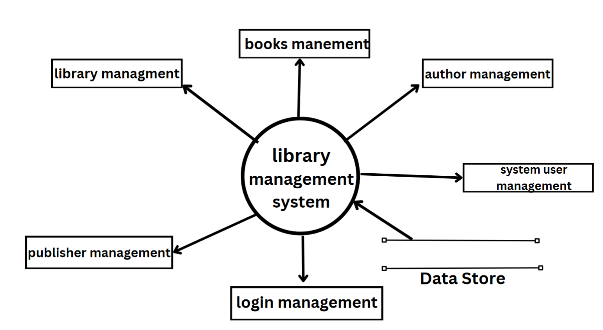

Level 1:

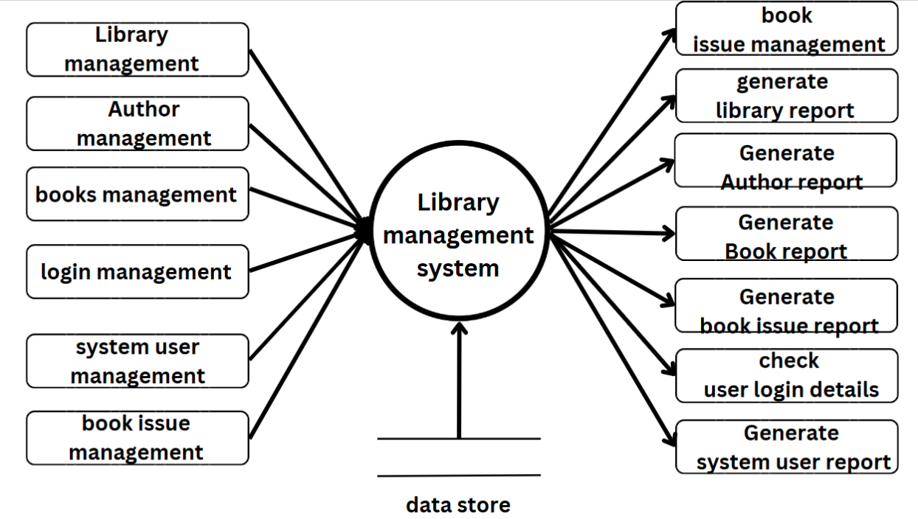

Level 2:

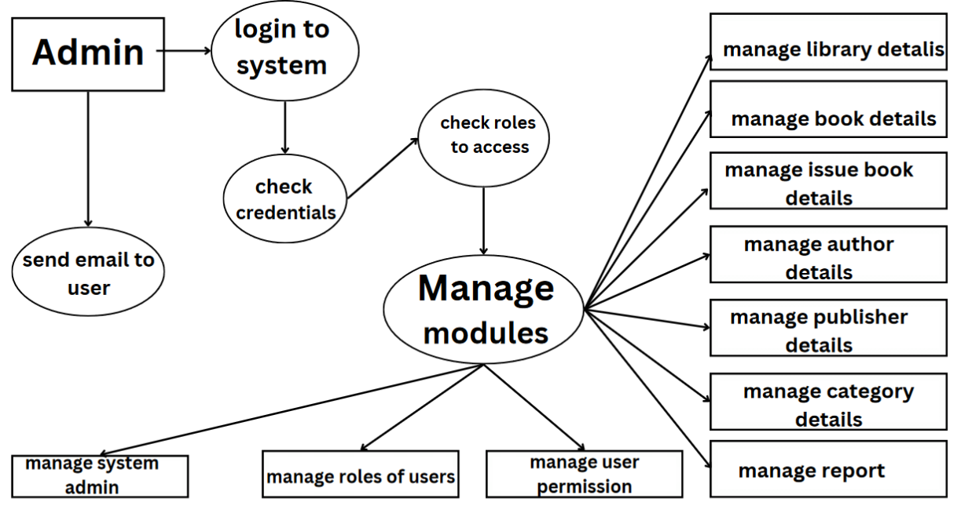

Sequence Diagram:

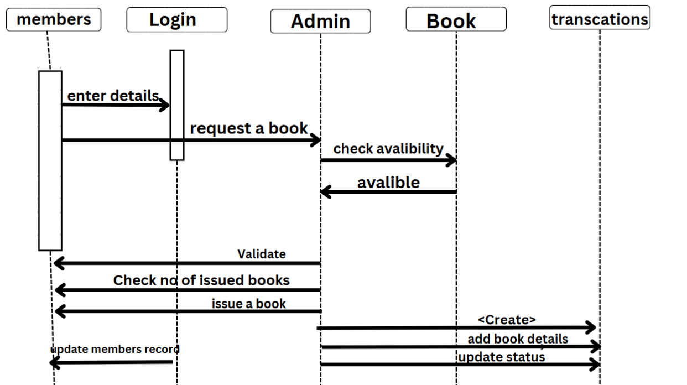

ER Diagram:

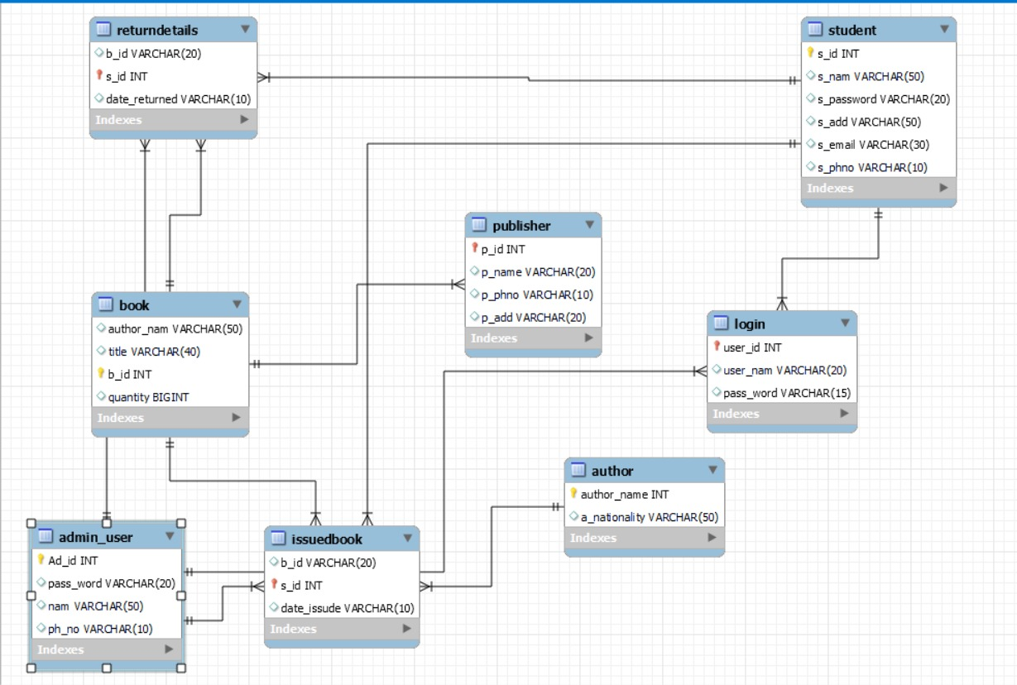

Class Diagram:

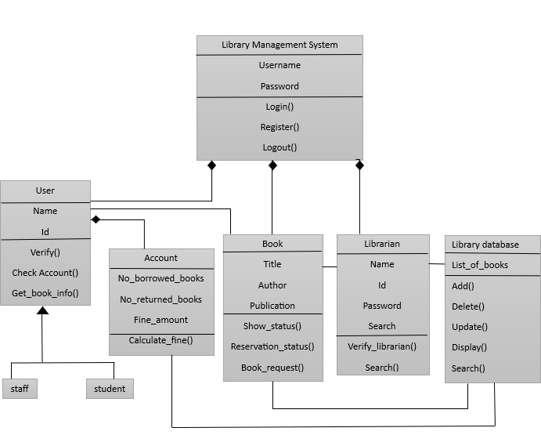

Component Diagram:

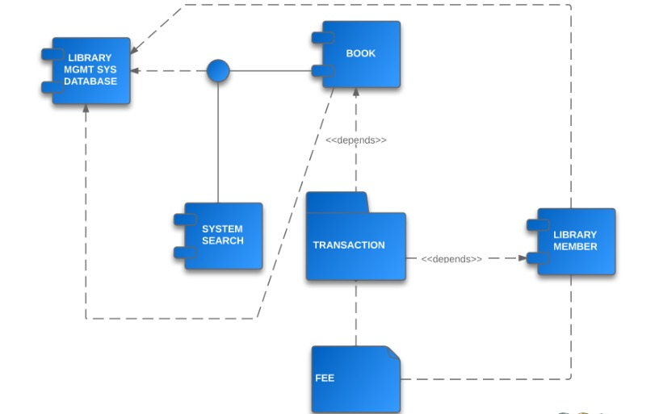

Use Case Diagram:

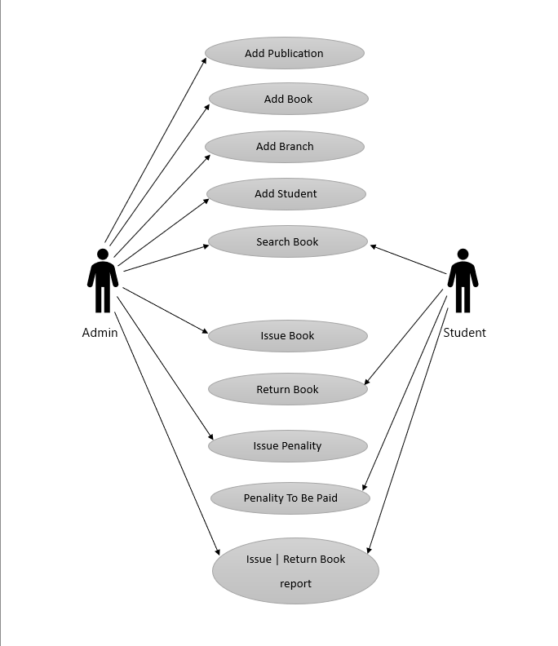

1. Results/Screenshots

Homepage:

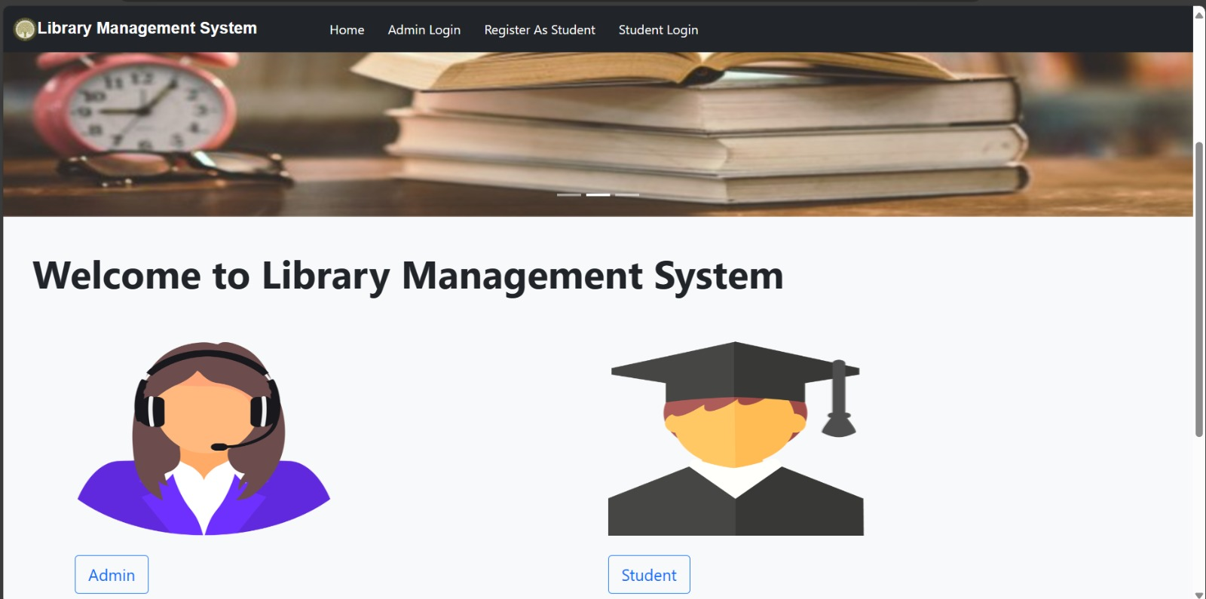

Student Registration:

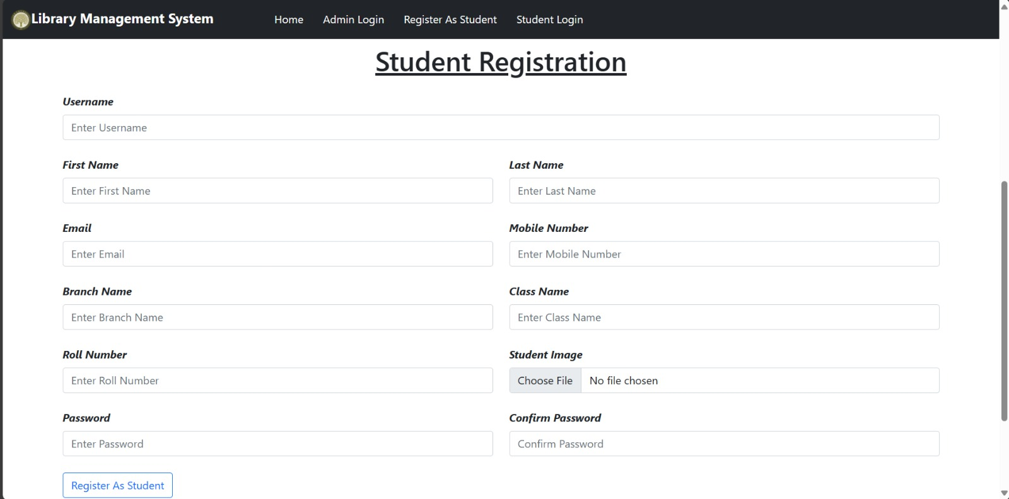

Login (Admin/Student):

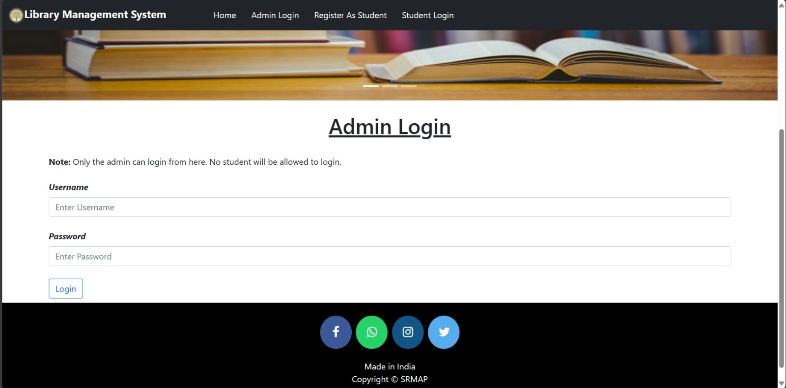

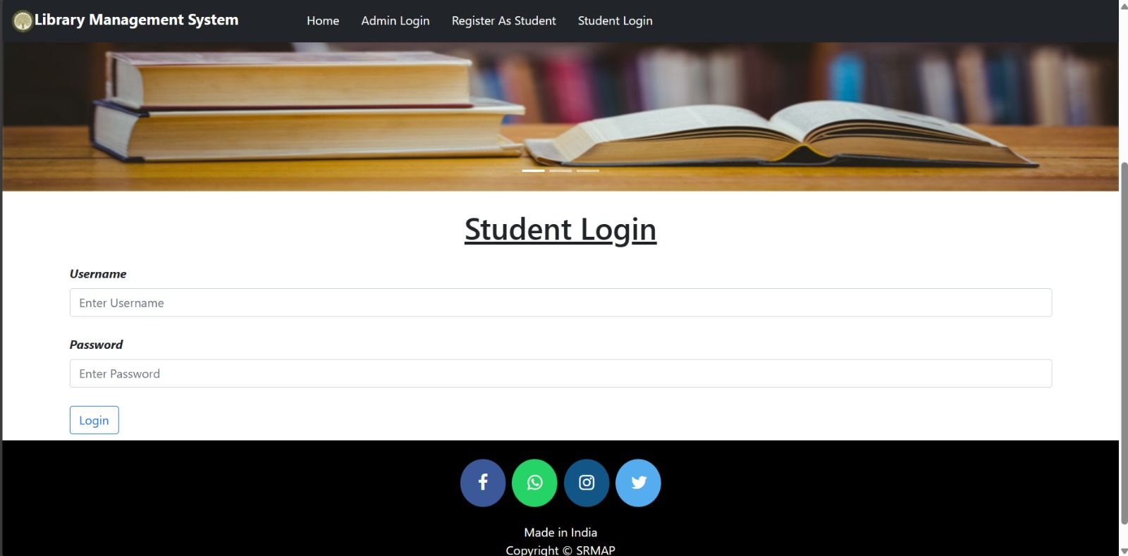

Admin: View All Students:

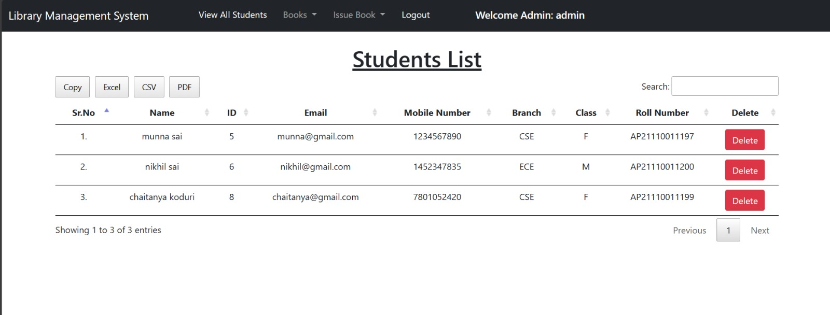

Admin: Add Book/All Book list:

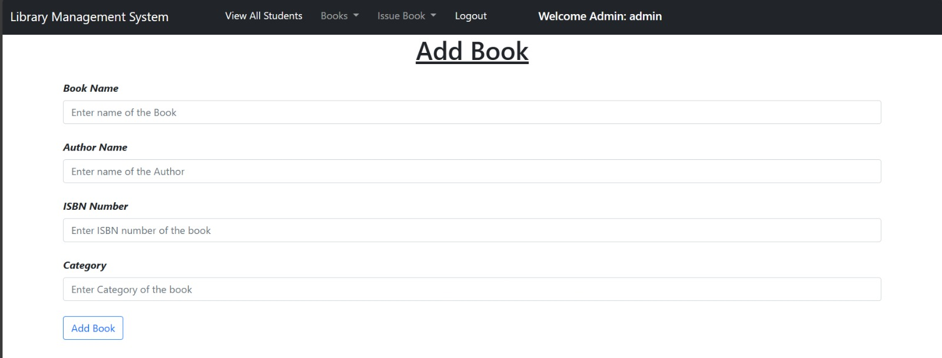

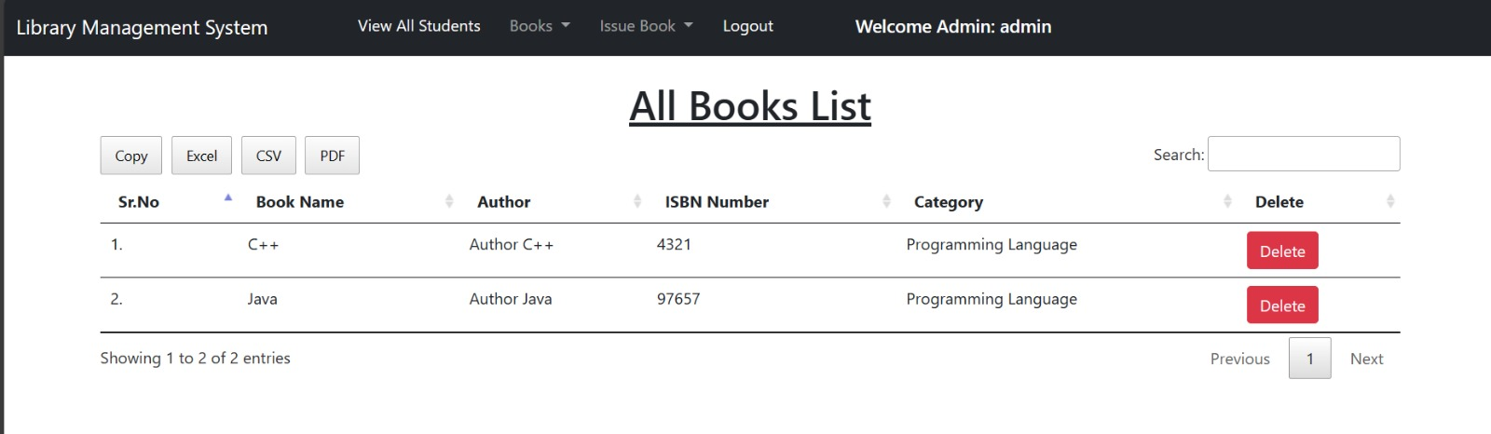

Admin: Issue a Book:

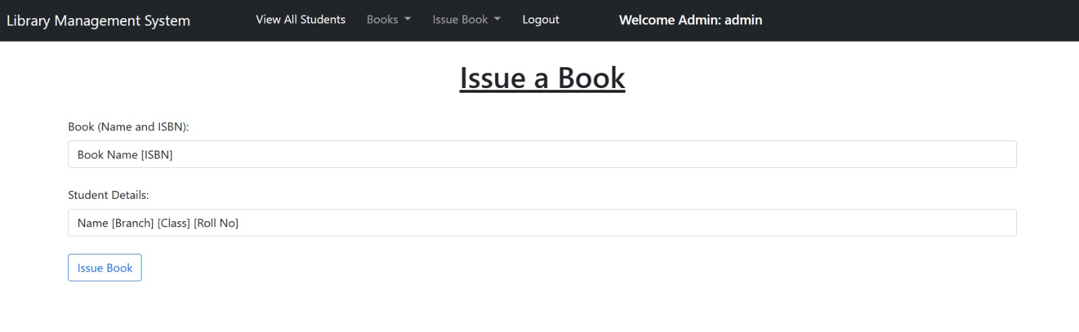

Admin: View All Issued Books To Students:

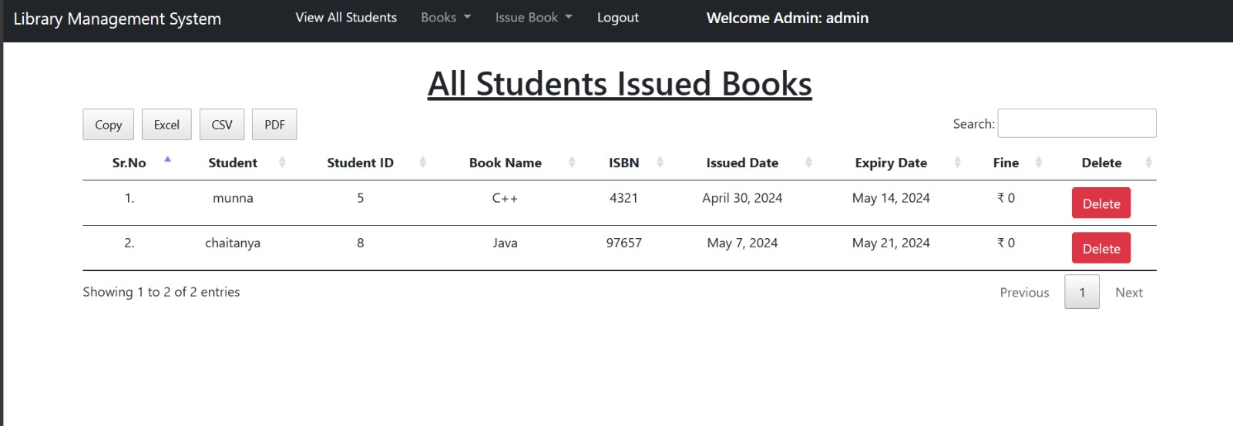

Admin Superuser:

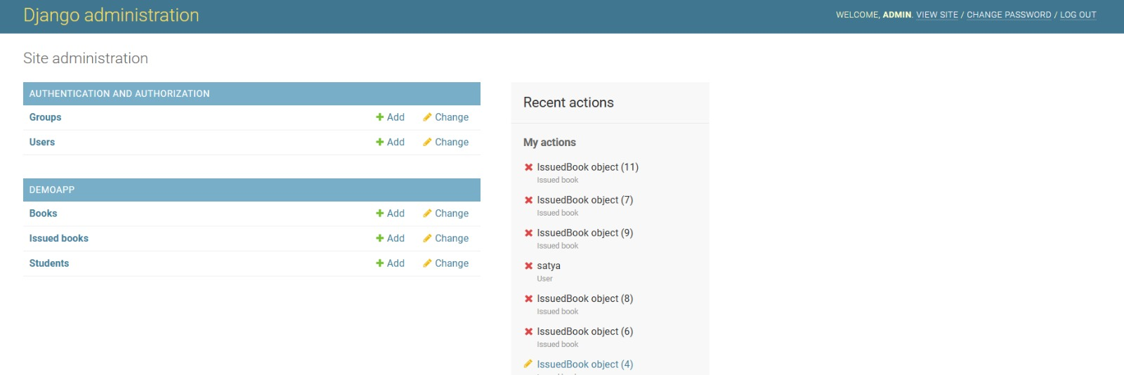

1. Conclusion

The library management system is like a super helpful assistant for libraries. It makes things easier by organizing books, keeping track of who borrows them, and helping librarians manage everything smoothly. This system is a big win for both librarians and library users, making the whole library experience better for everyone involved.

1. References

Bootstrap:

https://getbootstrap.com/docs/5.0/getting-started/introduction/

Plantuml:

https://www.plantuml.com/plantuml/uml/SyfFKj2rKt3CoKnELR1Io4ZDoSa70000